Check for Understanding

Practice labeling this prokaryotic cell below.
- Cell wall
- Cell membrane
- Ribosomes
- Flagellum
- Capsule
- Chromosome
- Nucleoid region
- Pili

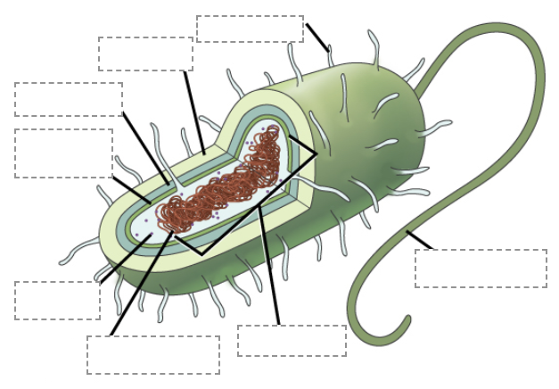

Bonus Practice

Research and describe what each prokaryotic component’s main and secondary functions are:

- Cell wall: ______________________________________________________________
- Cell membrane: _________________________________________________________
- Ribosomes: ____________________________________________________________
- Flagellum: _____________________________________________________________
- Capsule: ______________________________________________________________
- Chromosome: __________________________________________________________
- Nucleoid region: _________________________________________________________
- Pili: ___________________________________________________________________

